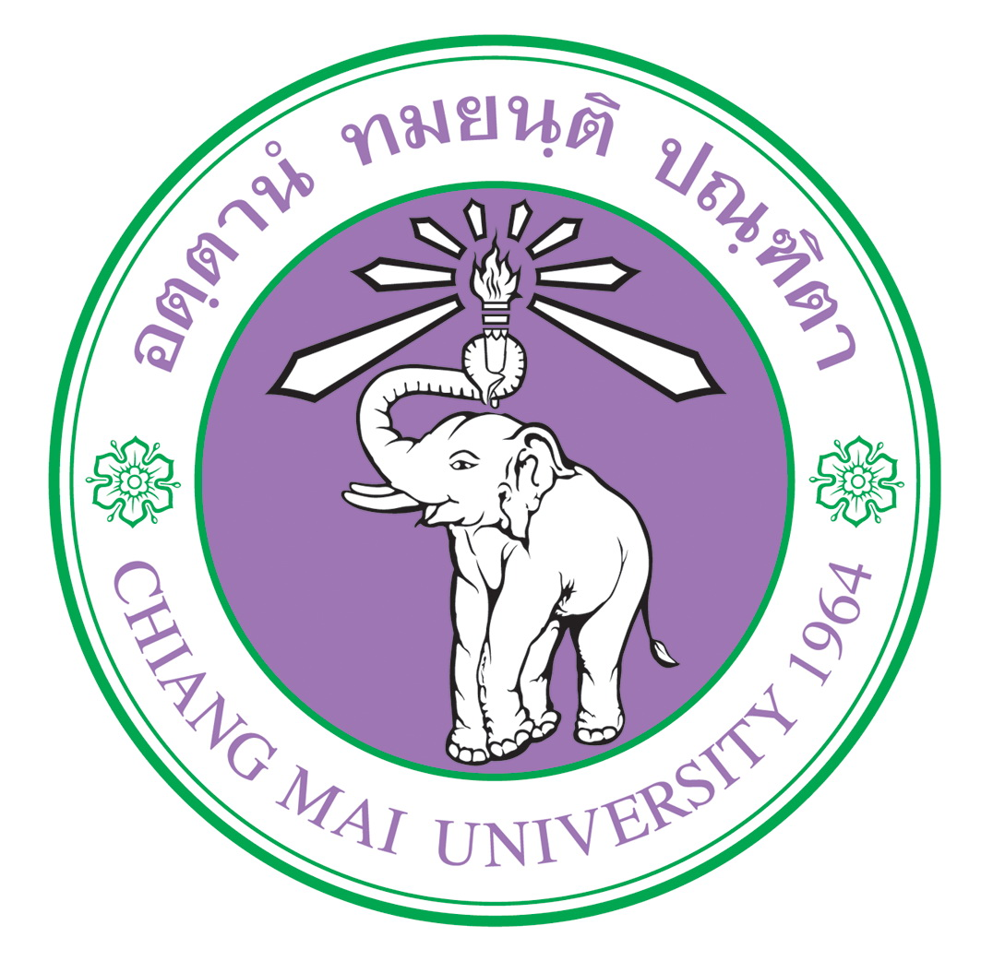
Please type

Application Form

Name | (Thai)
Name | ( English)
Student ID
Gender |  |  | Nationality
Date of Birth
Passport No. |  |  |  |  |  |  | Expired Date
Telephone |  |  |  |  |  | Line ID
E-Mail
Faculty
Major
School Year |  Undergraduate   Master   Doctoral |  |  |  |  |  |  |  1st year   2nd year   3rd year   4th year
Expected date to finish enrollment at CMU |  |  |  |  |  |  |  | DD/MM/YYYY
Name of Exchange Program
Host University
Program Period |  |  1 Semester |  |  2 Semesters |  |  |  |  |  Other ______________
 |  | From DD/MM/YYYY to DD/MM/YYYY

Applicant’s Signature Date: Day/ Month / Year

____

